**Lab Exam**

The delivered report is very important in grading, please illustrate everything clearly.

**Notes & Hints:**

1. Make sure you solve all the problems first, and then try to enhance more.
2. Before jumping into any complicated solution, take your time to think first. Most probably, the solution is simpler than you think.
3. Take your time in choosing the most appropriate method (and threshold/parameter - if applicable).
4. Your exam time is 60 minutes. Use it wisely.
5. Stick to the requirements and the delivery notes, any violation to delivery notes will be penalized even if your code is perfect.
6. Make sure to open the images and examine them well before solving.
7. **Take care of any needed conversions in image types or pixel value ranges.**
8. After the time is over, kindly leave your report and leave the room. Any further writing in the code or the document will be penalized.
9. No two problems should be solved in the same cell.
10. If the problem contains more than one image, solve it for all images as indicated in the question, and show the output for each Image.
11. Show all output image(s) clearly in each stage of the solution.
12. Make sure the image paths in the code are relative paths, so that your code can work even if it is moved.
13. This sheet and output images are very important in evaluation.
14. Don’t forget to write your solutions here and to show the output in the notebook.
15. Deliver your report to the TA and put your notebook/images on a folder on your desktop named “IPLE_C_F2022_YOURNAME”. The notebook should be named the same as the folder. Your name should be written as a comment in the start of the first cell of your notebook.

**Some coding imports & tips that might be useful:**

from skimage.color import rgb2gray,rgb2hsv,hsv2rgb

from scipy.signal import convolve2d

*Check the commonfunctions.py file for more*

**Juptyer notebook useful shortcuts:**

To show the prototype a function: (shift + tab) inside the parentheses of the function call.

For auto-complete: (tab).

**Questions**

**Do your best and solve as much as you can**

**Question 1**

For the given image (Q1.jpg), identify the existing issue(s). Use 3 different methods to improve the image, clearly indicating your choice of parameters (if any) and commenting on your results.

Issue(s): …..……………………………………………………………………………………….

| **Method** | **Parameters** | **Comments** |
| --- | --- | --- |
|  |  |  |
|  |  |  |
|  |  |  |

**Question 2**

Given the image (Q2.png), create an output image showing the centers of the circles in the original image. If applicable, clearly indicate any parameters used and justify your choice. The output should look as follows:

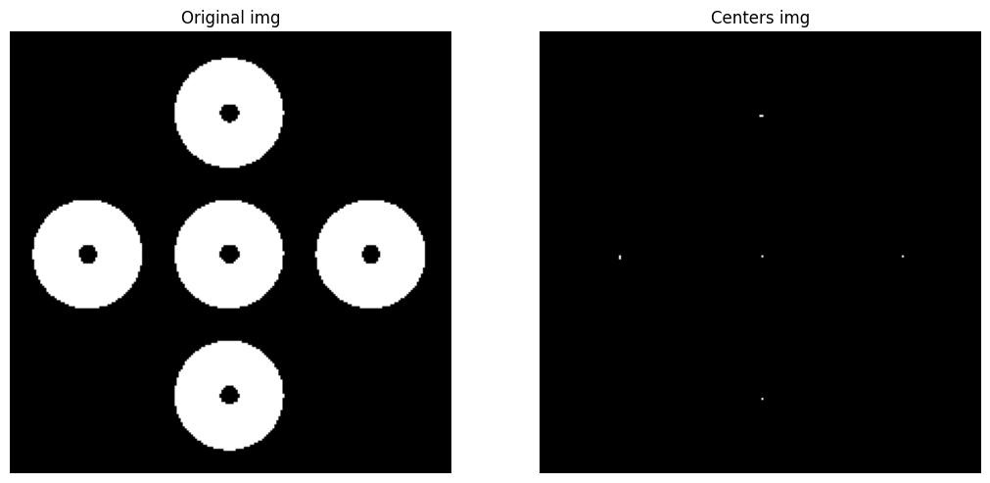

**Question 3**

The given image (Q3.jpg) has been processed to give the output shown below. Perform some of the image processing techniques you learned to get a similar output.

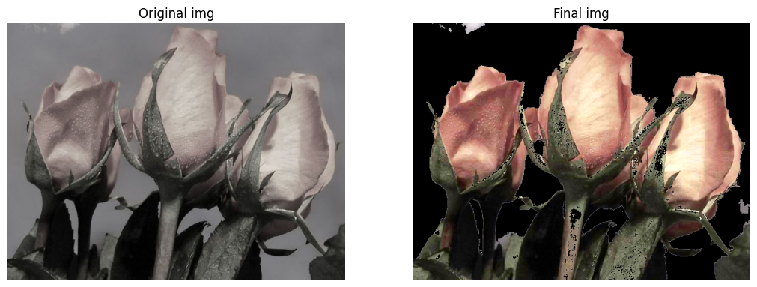

What problem(s) does the original image have?  
………………………………………………………………………………………………………  
Which step(s) did you follow to solve it?

………………………………………………………………………………………………………

Can you think of a real-life application where this might be useful?

………………………………………………………………………………………………………

**Question 4**

Create 2 grayscale images having identical histograms but different textures. **(Note: it’s not allowed to make the second image a rotation of the first one. You have to create a totally different image.)**

What methods can you use to differentiate between textures?  
………………………………………………………………………………………………………